Software Requirement Specification

for
AutoAid
FYP Team

Umar Anjum 22F-3292
Mustehsan Nisar 22F-3281
Umair Anjum 22F-3293

Supervised By
Mam Aqsa Younas



Department of Software Engineering
FAST – National University of Computer & Emerging Sciences
Chiniot-Faisalabad Campus
2025

Table of Contents
1 Introduction 1
2 Vision Document 1
2.1 Problem Statement 1
2.2 Business Opportunity 2
2.3 Objectives 3
2.4 Scope 3
2.5 Constraints 4
2.6 Stakeholder and User Descriptions 4
2.6.1 Market Demographics 4
2.6.2 Stakeholder Summary 5
2.6.3 User Environment 6
2.6.4 Stakeholder Profiles 7
3 System Requirements Specification 9
3.1 System Features 9
3.2 Functional Requirements 10
3.2.1 User Registration & Authentication 10
3.2.2 Breakdown Assistance (Mechanics) 11
3.2.3 Temporary Driver Assistance (AI-Powered) 12
3.2.4 Fuel Delivery Service 12
3.2.5 Admin Approval 13
3.2.6 Jumpstart Service 13
3.2.7 Lockout Assistance 13
3.2.8 Towing Service 14
3.2.9 NHA Route Announcements 15
3.3 Nonfunctional Requirements 15
3.3.1 Security 15
3.3.2 Performance 16
3.3.3 Usability 16
4 Use Case Models 17
4.1 High level Use Cases 17
4.2 Use Case Diagram 19
4.3 Expanded Use Cases 20
4.3.1 Use Case 1: 20
4.3.2 Use Case 2: 21
4.3.3 Use Case 3: 23
4.3.4 Use Case 4: 24
4.3.5 Use Case 5: 25
4.3.6 Use Case 6: 26
4.3.7 Use Case 7: 27
4.4 System sequence Diagram 29
4.4.1 Login 29
4.4.2 Breakdown Assistance 30
4.4.3 Temporary Driver 31
4.4.4 Fuel Delivery 32
4.4.5 Lockout 33
4.4.6 Towing 34
4.4.7 Admin Approvals for Registration 35
4.4.8 Resolve Dispute 36
4.4.9 Manage Request 37
5 Design Phase Artifacts 26
5.1 Behavioral Design 26
5.1.1 Activity Diagram 26
5.1.2 DFD 27
5.2 Structural Design 31
5.2.1 Domain Model 31
5.2.2 Component Diagram 32
5.2.3 Package Diagram 33
5.3 Database Design 34

Introduction
AutoAid is a web-based platform designed to address vehicle-related emergencies in Pakistan, such as mechanical breakdowns, fuel shortages, dead batteries, lockouts, towing services, and driver unavailability. By integrating real-time geolocation, a MERN stack (MongoDB, Express.js, React.js, Node.js), and an AI-powered Driver Recommendation Engine, AutoAid connects vehicle owners with trusted mechanics, temporary drivers, petrol pump owners, and roadside assistance providers (e.g., jumpstart, lockout, towing services). The platform also incorporates National Highway Authority (NHA) announcements to alert users about roadblocks due to construction, protests, or accidents, enhancing safety for long trips. In Pakistan’s fast-paced urban and rural environments, where fragmented solutions (e.g., separate ride-hailing or fuel apps) cause delays and stress, AutoAid offers a unified, human-centered solution. It prioritizes trust, safety, and convenience through secure authentication, role-based dashboards, and AI-driven personalization, making it a critical tool for vehicle owners and service providers.

Vision Document

Problem Statement
Problem Area | Description | Impact | Proposed Solution
Mechanical Breakdowns | Vehicles experience sudden mechanical failures (e.g., engine issues) requiring immediate repair. | Delays, safety risks, and stress, especially in remote or urban traffic areas. | Unified platform connects users with nearby certified mechanics using geolocation.
Fuel Shortages | Running out of fuel in inconvenient locations, particularly in rural areas or traffic jams. | Stranded users, wasted time, and potential safety hazards at night or in unfamiliar areas. | Real-time fuel delivery service with ETA and cost estimates from petrol pumps.
Driver Unavailability | Lack of a driver during critical times (e.g., late nights, long trips). | Inability to travel, missed appointments, or reliance on untrusted sources. | AI-driven temporary driver matching based on preferences, ratings, and safety.
Dead Batteries | Vehicles with dead batteries needing jumpstarts, common in extreme weather. | Delays and risks of being stranded, especially without proper tools or knowledge. | Jumpstart service with certified providers and AI prioritization for reliability.
Vehicle Lockouts | Accidental locking of vehicles, leaving owners unable to access them. | Security concerns, delays, and potential damage from improper entry attempts. | Lockout assistance connecting users with verified locksmiths via AI recommendations.
Non-Repairable Issues | Vehicles requiring towing due to severe breakdowns or accidents. | High costs, logistical challenges, and safety risks if not addressed quickly. | Towing service with real-time tracking and provider compatibility matching.
Roadblocks on Highways | Unannounced blockages due to construction, protests, or accidents, affecting long trips. | Delays, rerouting difficulties, and safety hazards without prior knowledge. | Integration of NHA announcements for real-time route advisories and alternatives.
Fragmented Solutions | Reliance on multiple apps (e.g., ride-hailing, fuel delivery) or manual searches. | Time-consuming, inefficient, and lack of trust/safety focus in current platforms. | Unified platform integrating all services with AI and geolocation for seamless use.

Business Opportunity
The increasing number of vehicles in Pakistan (over 5 million registered vehicles as of recent estimates) and frequent road-related challenges (e.g., breakdowns, traffic disruptions) create a significant demand for a reliable, all-in-one emergency assistance platform. Urban areas like Karachi and Lahore face high traffic congestion, while rural areas lack quick access to services, amplifying the need for AutoAid’s geolocation-based solutions. Existing apps (e.g., Careem, local fuel delivery startups) are siloed, creating an opportunity for a unified platform. AutoAid’s AI-driven personalization, integration with local systems (e.g., NHA), and focus on safety (via ratings, certifications) position it to capture the market of vehicle owners, service providers, and fleet managers. Potential revenue streams include service fees, and partnerships with petrol pumps or garages. By addressing Pakistan-specific needs, AutoAid can scale to other developing markets with similar challenges.

Objectives
- Develop a web-based platform using the MERN stack to connect vehicle owners with mechanics, drivers, petrol pumps, and roadside assistance providers (jumpstart, lockout, towing).
- Implement real-time geolocation for locating nearby service providers and tracking service status.
- Ensure secure role-based registration and authentication with OTP and document verification.
- Provide an admin panel for provider approvals, activity monitoring, and dispute resolution.
- Integrate an AI-powered recommendation engine for personalized driver and service provider matching based on preferences, ratings, and trip details.
- Incorporate roadside assistance modules for jumpstarts, lockouts, and towing to address diverse emergencies.
- Integrate NHA announcements via API or web scraping to provide real-time route advisories for long trips.

Scope
The AutoAid platform includes:
- User Registration and Authentication: Role-based accounts (vehicle owners, mechanics, drivers, petrol pumps, admins) with OTP and document verification.
- Breakdown Assistance: Geolocation-based mechanic search, request submission, and status tracking.
- Temporary Driver Assistance: AI-driven driver matches preferences, ratings, and trip details.
- Fuel Delivery Service: Request fuel type/quantity, view ETA/cost, and track delivery.
- Admin Approval: Manage provider registrations, monitor activities, and resolve disputes.
- Jumpstart Service: Locate providers for dead batteries with AI ranking and real-time tracking.
- Lockout Assistance: Connect users with locksmiths, ensuring secure access and AI recommendations.
- Towing Service: Arrange towing for immovable vehicles with provider tracking.
- Route Advisory: Fetch NHA announcements for roadblocks and suggest alternative routes.

Constraints
Technical Constraints:
- Dependency on internet connectivity for real-time geolocation and updates, challenging in rural Pakistan with inconsistent networks.
- Limited availability of reliable NHA APIs, requiring web scraping (e.g., BeautifulSoup), which may face legal or stability issues.
Resource Constraints:
- Development limited to a team of three students with a 6–8 month timeline, restricting feature depth.
- Hardware limited to development PCs (Windows 10/11, 8 GB RAM), potentially slowing AI training.
Regulatory Constraints:
- Provider certifications (e.g., mechanic licenses) require manual verification, adding admin workload.
Operational Constraints:
- Limited initial provider networks may reduce service availability in less populated areas.
- User adoption may be slow due to competition from established apps.

Stakeholder and User Descriptions

Market Demographics
- Vehicle Owners: Urban and rural residents aged 18–60, primarily male (due to driving demographics in Pakistan), owning cars. Includes daily commuters, long-distance travelers, and fleet operators (e.g., small businesses). Estimated market: ~5 million vehicle owners (based on Pakistan’s vehicle registration data).
- Service Providers: Mechanics, professional drivers, petrol pump owners, and roadside assistance providers (jumpstart, lockout, towing), aged 18–50, mostly male, operating in urban centers (e.g., Lahore, Karachi) and highways. Likely tech-savvy enough to use dashboards.
- Admins: Internal platform managers, likely 1–3 per region, aged 25–40, with technical or customer service backgrounds.
- Demographic Trends: Growing vehicle ownership (5% annual increase), rising smartphone penetration (50%+ in urban areas), and increasing demand for emergency services due to infrastructure challenges.

Stakeholder Summary
Stakeholder | Role/Responsibility | Interest in Project | Influence/Impact
Vehicle Owners | End-users seeking emergency assistance (e.g., breakdowns, fuel, drivers). | Fast, reliable, and safe solutions for vehicle emergencies. | High; drive demand and provide feedback for improvement.
Mechanics | Service providers repairing vehicles via geolocation-based requests. | Steady job opportunities, fair payments, and reputation building via ratings. | Medium; supply service capacity and affect user trust.
Drivers | Professional drivers matched to users via AI recommendations. | Safe trip assignments, clear details, and timely compensation. | Medium; ensure service quality and user satisfaction.
Petrol Pump Owners | Providers managing fuel delivery requests and logistics. | Efficient order handling, integration with delivery systems, and revenue growth. | Medium; critical for fuel service availability.
Jumpstart Providers | Certified technicians offering battery jumpstart services. | Job opportunities, tool verification, and real-time tracking support. | Medium; enhance roadside assistance coverage.
Lockout Providers | Locksmiths or specialists assisting with vehicle access issues. | Secure job assignments, identity verification, and reliable income. | Medium; address a niche emergency need.
Towing Providers | Operators handling vehicle towing for non-repairable issues. | Compatible vehicle matching, real-time tracking, and fair compensation. | Medium; critical for severe breakdowns.
Admins | Platform managers approving providers, monitoring activities, and resolving disputes. | Platform integrity, user safety, and operational efficiency. | High; oversee quality and enforce policies.
National Highway Authority (NHA) | External data source providing roadblock announcements. | Accurate, real-time data for route advisories. | Medium; impacts trip planning and safety features.
Payment Providers | Facilitate secure payment transactions for services. | Seamless integration and transaction reliability. | Medium; ensures financial transactions and trust.
Regulatory Bodies | Oversee data protection and compliance (e.g., Pakistan’s Personal Data Protection Bill). | Legal compliance and user data security. | High; enforce regulatory adherence and mitigate risks.

User Environment
Vehicle Owners: Use AutoAid via web browsers on smartphones or laptops, often in high-stress roadside situations (e.g., breakdowns, fuel shortages). Environments range from urban traffic jams to remote highways with variable internet (3G/4G, spotty in rural areas).
Service Providers: Access dashboards on smartphones or PCs in workshops, petrol pumps, or on the move. Require stable internet for real-time updates.
Admins: Operate from office settings with reliable PCs and internet, managing high volumes of data.
Technical Context: Web-based platform (React.js frontend), accessible on Chrome/Firefox, with geolocation enabled. Rural users may face connectivity issues, requiring lightweight UI.

Stakeholder Profiles

Supervisor Team
Representative | Supervisor: Mam Aqsa Younas
Description | They are involved in supervising activities for the development process of AutoAid.
Type | They are technical stakeholders. They have expertise in MERN stack, AI, and real-time systems.
Responsibility | 1. Guides MERN stack implementation and AI integration.  2. Ensures project completion within 6–8 months.  3. Validates market demand for roadside assistance in Pakistan.  4. Tracks use case implementation and NHA integration.  5. Ensures team follows SRS, UML, and design artifacts.  6. Reviews of swimlane diagrams, DFDs, and sequence diagrams.  7. Confirms final demo includes real-time tracking and OTP login.
Success Criteria | Full implementation of core modules (Breakdown, Fuel, Lockout, Towing, Driver, NHA Alerts) with 95% test coverage.
Involvement | 1. Weekly SRS & UML review  2. Mid-term and final demo evaluation  3. Guidance on AI recommendation engine
Comments/Issues | Ensure NHA scraping is stable; fallback plan needed.

Development Team
Representative | Umar Anjum (22F-3292)  Mustehsan Nisar (22F-3281)  Umair Anjum (22F-3293)
Description | They are involved in the development of the AutoAid project.
Type | Technical stakeholders (FYP Students).
Responsibility | 1. Fully involved in the development of the MERN stack platform.  2. Specify functional and non-functional requirements.  3. Conduct research on AI recommendation engine, NHA web scraping, and real-time geolocation.  4. Successful development of proposed modules (Breakdown, Fuel, Jumpstart, Lockout, Towing, Driver, NHA Alerts)
Success Criteria | Successful completion and deployment of committed features with live demo.
Involvement | 1. Development of the project.  2. Documentation (SRS, UML diagrams, Swimlane, DFD, Use Cases) and full-stack development
Comments/Issues | Ensure NHA scraping is stable; fallback plan needed.

End User
Representative | Vehicle Owners, Mechanics, Temporary Drivers, Petrol Pump Owners, Lockout / Towing Providers
Description | They are the end users of the AutoAid platform who use it to request or provide roadside assistance services.
Type | External stakeholders
Responsibility | 1. Vehicle Owners: Submit accurate emergency requests.  2. Service Providers: Respond promptly, update status, and deliver quality service.  3. All: Follow platform guidelines and provide honest feedback.
Involvement | 1. Register and verify accounts  2. Use real-time tracking and NHA alerts  3. Rate services and resolve disputes via app
Comments/Issues | Ensure app works in low-connectivity areas (rural roads)

System Requirements Specification

System Features
User Management and Authentication
- Provides role-based registration and authentication for vehicle owners, mechanics, drivers, petrol pump owners, jumpstart/lockout/towing providers, and admins.
- Supports secure login with OTP verification and document uploads for provider validation.
- Ensures profile management with availability schedules and pricing details for service providers.
Emergency Service Request and Matching
- Enables users to request assistance for breakdowns, fuel delivery, jumpstarts, lockouts, towing, and temporary drivers via a geolocation-based interface.
- Integrates an AI-powered recommendation engine to match users with the most compatible and reliable providers based on preferences, ratings, and historical data.
- Offers real-time tracking of provider locations and service statuses for transparency.
Roadside Assistance Modules
- Facilitates immediate jumpstart services by connecting users with certified providers equipped with necessary tools, prioritized by AI.
- Provides lockout assistance by linking users with verified locksmiths, ensuring secure vehicle access with identity verification.
- Arranges towing services for non-repairable vehicles, including provider compatibility matching and real-time tracking.
Fuel Delivery Service
- Allows users to locate nearby petrol pumps offering delivery and request specific fuel types and quantities.
- Displays estimated delivery times and costs, with real-time updates managed through provider dashboards.
- Supports feedback and rating systems to improve service quality over time.
Route Planning and Advisory
- Enables users to input trip routes and receive real-time announcements from the National Highway Authority (NHA) about roadblocks due to construction, protests, or accidents.
- Suggests alternative routes based on NHA data, integrated with driver assistance for long trips.
Administrative Oversight
- Offers an admin panel for approving provider registrations, monitoring platform activities, and resolving disputes.
- Maintains audit logs of admin actions and flags suspicious activities for enhanced security.
- Ensures a safe environment through provider suspension/banning and dispute resolution mechanisms.
Feedback and Quality Control
- Collects user feedback and ratings post-service for all modules (e.g., mechanics, drivers, fuel delivery) to refine AI recommendations.
- Provides a mechanism for users and providers to report issues, feeding into admin dispute resolution.
Integration and Scalability
- Integrates with external systems like NHA (via API or web scraping) and payment providers for seamless data and transaction flow.
- Supports scalability to handle growing user bases and concurrent requests using MongoDB’s geospatial capabilities and Node.js’s non-blocking I/O.

Functional Requirements

User Registration & Authentication
- The system shall allow users to register under distinct roles: Vehicle Owner, Mechanic, Towing Service Provider, Driver, and Petrol Pump Owner.
- The system shall collect and store essential information including personal details, contact data, and role-specific attributes.
- The system shall verify user identity using a secure One-Time Password (OTP) sent via email.
- The system enables Mechanics and Drivers to upload verification documents (e.g., license, certifications, ID proofs) for validation.
- The system shall allow service providers to define and update their availability schedules and pricing details within their profiles.
- The system should authenticate users securely using registered credentials and shall provide password-recovery or reset functionality.
- The system shall implement role-based access control, ensuring that users only access features permitted for their selected roles.
- The system shall permit users to update personal information, manage documents, and modify login credentials from a dedicated profile dashboard.
- The system shall notify users of successful registration, fail authentication, or pending verification status through alerts or messages.

Breakdown Assistance (Mechanics)
- The system shall automatically detect a Vehicle Owner’s real-time location using GPS when a breakdown request is initiated.
- The system shall display a ranked list of available mechanics nearby, including distance, ratings, estimated time of arrival (ETA), and service fees.
- The system shall allow the user to describe the breakdown issue via text, voice, or image before submitting a request.
- The system shall forward the request and issue details to nearby mechanics in real time.
- The system shall provide mechanics with a dedicated dashboard to view, accept, or reject incoming assistance requests.
- The system should update and notify the Vehicle Owner when a mechanic accepts or declines the request.
- The system shall provide estimated arrival tracking once a mechanic has accepted a job, displaying their live location and ETA.
- The system shall allow Vehicle Owners to rate and review mechanics after the service is completed, updating the mechanic’s performance record.
- The system shall reroute requests to alternative mechanics automatically if the selected mechanic does not respond within a defined time limit.

Temporary Driver Assistance (AI-Powered)
- The system shall allow Vehicle Owners to request temporary driving assistance by entering trip details (pickup point, destination, time, and duration).
- The system shall identify nearby available professional drivers using real-time GPS data.
- The system shall display driver profiles containing license information, experience, ratings, availability, and pricing.
- The system shall integrate an AI Recommendation Engine to rank drivers not only by proximity but by overall compatibility and safety.
- The AI engine shall consider parameters such as user preferences (e.g., gender, language, comfort level), trip details (route, duration, time), and past reviews.
- The AI engine shall compute and display a Safety and Trust Score for each driver to support informed selection.
- The system shall allow the Vehicle Owner to send a booking request to a chosen driver and shall notify the driver for acceptance or rejection.
- Upon driver acceptance, the system shall share trip details, estimated arrival, and driver contact information with the Vehicle Owner.
- The system shall enable real-time tracking of the driver’s approach and trip status throughout the service.

Fuel Delivery Service
- The system must allow users to locate petrol pumps offering delivery services using geolocation.
- Users must specify fuel type (e.g., petrol, diesel) and quantity in a request form.
- The system must display nearby petrol pumps with details (distance, ratings, fuel availability).
- The system must calculate and provide estimated delivery time (ETA) and cost for user confirmation.
- Petrol pump owners must manage requests via a dashboard, accepting/rejecting and updating status (e.g., dispatched, delivered).
- The system must provide real-time tracking of delivery status and vehicle location (if shared).
- Users submit feedback and ratings for petrol pumps post-delivery.

Admin Approval
- The system must allow admins to view and approve/reject provider registrations (mechanics, drivers, petrol pumps) with feedback.
- Admins must access a dashboard displaying real-time metrics (e.g., active users, requests) with role/time/location filters.
- The system must provide a dispute log for admins to review and resolve issues (e.g., refunds, suspensions).
- Admins must ban or suspend users/providers for policy violations (e.g., fake documents).
- The system must maintain audit logs of all admin actions with timestamps for accountability.
- The system must notify providers of approval/rejection status via email or dashboard.

Jumpstart Service
- The system must allow users to request jumpstart assistance with vehicle details (e.g., battery type) using geolocation.
- The system must display nearby certified providers with equipment details, ratings, and ETA.
- The AI engine must rank providers based on user preferences, historical reliability, and equipment compatibility.
- Users must select a provider or allow auto-assignment by the system.
- Providers must confirm tool availability (e.g., jumper cables) via a dashboard before accepting requests.
- The system must provide real-time notifications of request status and provider location (if shared).
- Users must submit feedback and ratings post-service for AI model updates.

Lockout Assistance
- The system shall allow Vehicle Owners to request lockout assistance by providing vehicle details (e.g., make, model) and their current location via a web interface.
- The system shall automatically detect the Vehicle Owner’s real-time location using GPS when a lockout request is initiated, with an option for manual location input.
- The system shall identify and display a ranked list of nearby locksmiths or specialized service providers, including distance, ratings, and estimated time of arrival (ETA).
- The system should integrate an AI Recommendation Engine to rank lockout service providers based on historical reliability, user preferences (e.g., experience, response time), and vehicle compatibility, displaying a trust score for each provider.
- The system shall forward the lockout request and issue details to nearby providers in real time.
- The system shall provide lockout service providers with a dedicated dashboard to view, accept, or reject incoming requests and update the status (e.g., accepted, on route, completed).
- The system shall require providers to verify the Vehicle Owner’s identity before granting vehicle access, logging verification details for security purposes.
- The system shall notify the Vehicle Owner when a provider accepts or declines the request and provides real-time tracking of the provider’s location and ETA upon acceptance.
- The system shall allow Vehicle Owners to rate and review lockout service providers after service completion, updating the provider’s trust score.

Towing Service
- The system shall allow a user to initiate a "Towing Service" request by specifying vehicle details (type, model, condition), pickup location, and destination.
- The system shall match the user's request with towing providers based on vehicle compatibility, provider proximity, cost estimates, and user ratings.
- The system shall ensure that matched towing providers have the required capacity and equipment for the user's specific vehicle type.
- The system shall calculate and display a fare estimate to the user based on distance and vehicle type before they confirm the request.
- The system shall provide towing providers with a dashboard to view, accept, or reject incoming towing requests.
- The system allows the assigned towing provider to update the job status (e.g., "Dispatched," "Vehicle Loaded," "In Transit," "Completed").
- The system shall provide the user with real-time tracking of the tow truck's location on an integrated map from the moment the request is accepted.
- The system shall calculate the final fare based on the actual distance traveled and present it transparently to the user upon trip completion.
- The system shall facilitate in-app payment upon service completion and prompt the user to rate the provider and provide feedback.

NHA Route Announcements
- The system shall allow Vehicle Owners to input their planned travel route by specifying start and end points or uploading a predefined route via the web interface.
- The system shall fetch real-time announcements from the National Highway Authority (NHA) regarding road or highway blockages due to construction, protests, accidents, or other disruptions using Python-based web scraping or REST APIs (if available).
- The system analyzes the user’s input route and cross-references with NHA announcements to identify and display disruptions, including details such as the cause, affected road segments, and estimated delay.
- The system shall suggest alternative routes to avoid identified disruptions, prioritizing safety and travel time efficiency, and display details such as distance and estimated travel time.
- The system shall periodically check for new NHA announcements during the user’s trip and provide real-time notifications of new disruptions or changes in road conditions.
- The system shall maintain a log of NHA announcements and alerts shown to the Vehicle Owner, accessible via their profile for future reference.
- The system allows users to manually refresh NHA announcements to check for updates before or during their trip.

Nonfunctional Requirements

Security
- The system must implement strong encryption (e.g., AES 256-bit) for all sensitive data, including passwords, documents, and location information.
- The system must hash and securely store user credentials to prevent unauthorized access.
- The system must ensure OTP generation and delivery through secure, tamper-resistant channels.
- The system must enforce access control policies to protect data segregation among user roles.

Performance
- The system must respond to user actions (e.g., searching for mechanics/drivers) within an average of 2–5 seconds.
- The system must update real-time GPS locations of users and service providers at intervals not exceeding 30 seconds.
- The AI Recommendation Engine must process and return ranked driver results within acceptable latency (≤ 5 seconds) for a smooth user experience.
- The system must handle concurrent user requests efficiently without noticeable degradation in response time.

Usability
- The interface must be intuitive and consistent across all user roles, minimizing the number of steps required to complete tasks.
- Critical operations such as sending breakdown or driver requests must require minimal input, suitable for emergency contexts.

Use Case Models

High level Use Cases
Section | Content/Explanation
Use Case ID | 1
Use Case Name | Register
Actor | New User (Vehicle Owner / Mechanic / Driver / Petrol-Pump Owner / Lockout Provider / Towing Provider)
Description | The new user selects a role, enters personal details, uploads required documents (for providers), receives an OTP, verifies it, and the system creates the account. Provider accounts are pending admin approval before activation.

Section | Content/Explanation
Use Case ID | 2
Use Case Name | Service Request
Actor | Vehicle Owner
Description | Owner selects service type (breakdown, fuel, jumpstart, lockout, towing, driver), adds details, and the system instantly matches with nearby verified providers.

Section | Content/Explanation
Use Case ID | 3
Use Case Name | Approve / Reject Service Provider
Actor | Admin
Description | Admin reviews uploaded documents (license, CNIC), approves or rejects registration, and system notifies the provider instantly.

Section | Content/Explanation
Use Case ID | 4
Use Case Name | Resolve Dispute
Actor | Admin
Description | Admin views dispute log, chats with both parties, issues refund / warning / suspension, and closes the case.

Section | Content/Explanation
Use Case ID | 5
Use Case Name | Manage Incoming Requests
Actor | Service Provider
Description | Provider views real-time requests on, confirms tools/availability, accepts job, updates status (en-route → arrived → completed).

Section | Content/Explanation
Use Case ID | 6
Use Case Name | Provide Feedback & Rating
Actor | Vehicle Owner
Description | After service completion, owner rates provider (1–5 stars) and writes optional review; rating updates.

Use Case Diagram
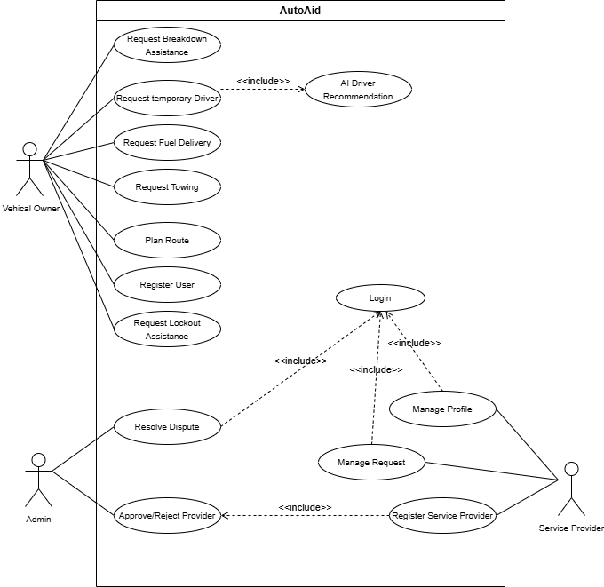

Expanded Use Cases

Use Case 1:
UseCase Id | 1
UseCase Name | Register/Login
Created By | Umar Anjum
Last Updated By | Umar Anjum
Date Created | 10/12/2025
Actor | User (Vehicle Owner or Service Provider)
Description | - A new user can register for an account, and an existing user can log in.  - For Service provider Registration is Approved by Admin
Trigger | User navigates to the registration or login page.
Pre-condition | - For Registration: User must not have an existing account.  - For Login: User must have a verified account.
Post-condition | User is successfully registered and/or logged into the system.
Normal flow | - User selects "Register" or "Login".  - For Registration:  - User selects a role (Vehicle Owner, Mechanic, Driver, etc.).  - User fills in details (Name, Email, Phone, Password).  - If a Service Provider, user uploads required documents.  - System sends an OTP to the provided phone/email.  - User enters the OTP to verify.  - System creates the account. For providers, status is "Pending Approval".  - For Login:  - User enters Email/Phone and Password.  - System validates credentials.  - User is granted access to their dashboard.
Alternative flow | - Invalid OTP: System displays an error and allows user to request a new OTP.  - Forgot Password: User can reset password via a link sent to their email/phone.
Exceptions | - Invalid data entry (e.g., duplicate email).  - System down or network issues.  - OTP service failure.
Includes | N/A
Frequency of use | Once per user for registration; frequent for login.
Special Requirements | Secure password hashing, OTP service integration, internet connection.

Use Case 2:
UseCase Id | 2
UseCase Name | Request Breakdown Assistance
Created By | Umar Anjum
Last Updated By | Umar Anjum
Date Created | 10/12/2025
Actor | Vehicle Owner
Description | A user requests mechanical help for a broken-down vehicle.
Trigger | User selects the "Breakdown Assistance" service.
Pre-condition | User has enabled location services.
Post-condition | A mechanic is assigned and dispatched to the user's location.
Normal flow | - User selects "Breakdown Assistance".  - System fetches the user's current location.  - System displays a list of nearby, available mechanics with ratings, ETA, and pricing.  - User selects a mechanic and provides a description of the vehicle issue.  - System sends a service request to the selected mechanic.  - Mechanic accepts the request.  - System notifies the user and provides the mechanic's live location and updated ETA.  - Upon completion, the mechanic marks the job as "Done".  - System prompts the user to rate the service and make payments.
Alternative flow | - No Mechanics Available: System notifies the user and suggests trying again later or using the Towing service.  - Mechanic Rejects: The request is automatically sent to the next available mechanic on the list.
Exceptions | - GPS fails to get location.  - User cancels the request after mechanic is assigned.
Includes | N/A
Frequency of use | Occasional (during vehicle emergencies).
Special Requirements | Real-time GPS tracking, push notifications.

Use Case 3:
UseCase Id | 3
UseCase Name | Request Temporary Driver
Created By | Umar Anjum
Last Updated By | Umar Anjum
Date Created | 10/12/2025
Actor | Vehicle Owner
Description | Vehicle Owner requests a temporary driver, with AI recommending matches based on preferences, ratings, and trip details.
Trigger | User needs a driver and initiates a request.
Pre-condition | User has enabled location services; trip details are ready.
Post-condition | Driver is assigned, and trip tracking begins.
Normal flow | - User enters preferences (e.g., gender, experience) and trip details.  - AI ranks drivers based on compatibility and safety scores.  - System displays list; user selects driver or auto-assigns.  - Driver accepts, system tracks trip.
Alternative flow | If no matches, system broadens search or notifies admin; user can cancel if unsatisfied.
Exceptions | Insufficient driver data, AI failure, network issues.
Includes | N/A
Frequency of use | Occasional (e.g., long trips or emergencies).
Special Requirements | AI processing within 1-3s; secure data transmission; offline fallback for rural areas.

Use Case 4:
UseCase Id | 4
UseCase Name | Manage Requests
Created By | Umar Anjum
Last Updated By | Umar Anjum
Date Created | 10/12/2025
Actor | Mechanic, Driver, Petrol Pump Owner, Lockout Provider, Towing Provider
Description | Service providers manage incoming requests (e.g., accept/reject, update status) via their dashboards.
Trigger | Provider receives a new request notification.
Pre-condition | Provider is logged in and available.
Post-condition | Request status is updated (e.g., accepted, en-route, completed).
Normal flow | - Provider views request details on dashboard.  - Provider accepts or rejects with reason.  - Provider updates status (e.g., en route, arrived, done).  - System notifies user.
Alternative flow | If provider rejects, system reassigns to another provider or notifies user to reselect.
Exceptions | Network failure, or provider unavailability.
Includes | N/A
Frequency of use | Frequent (multiple times daily based on demand).
Special Requirements | Real-time updates every 10s; intuitive UI with single-click actions.

Use Case 5:
UseCase Id | 5
UseCase Name | Approve Provider
Created By | Umar Anjum
Last Updated By | Umar Anjum
Date Created | 10/12/2025
Actor | Admin
Description | Admin reviews and approves or rejects provider registrations (e.g., mechanics, drivers) based on submitted documents.
Trigger | Admin receives a pending provider registration notification.
Pre-condition | Admin is logged in; pending registrations exist.
Post-condition | Provider is approved, rejected, or pending further review.
Normal flow | - Admin views provider details and documents.  - Admin verifies credentials (e.g., license).  - Admin approves or rejects with feedback.  - System notifies provider.
Alternative flow | If documents are incomplete, admin requests resubmission; if suspicious, escalates to manual review.
Exceptions | Document forgery, system error, or network issues.
Includes | N/A
Frequency of use | Periodic (as new providers register).
Special Requirements | Multi-factor authentication; encrypted document storage; 3s response time for approval.

Use Case 6:
UseCase Id | 6
UseCase Name | Resolve Dispute
Created By | Umar Anjum
Last Updated By | Umar Anjum
Date Created | 10/12/2025
Actor | Admin
Description | Admin investigates and resolves disputes (e.g., service complaints) between users and providers.
Trigger | User or provider reports a dispute.
Pre-condition | Admin is logged in; dispute log is accessible.
Post-condition | Dispute is resolved (e.g., refund issued, provider suspended).
Normal flow | - Admin reviews dispute details (logs, ratings).  - Admin contacts parties if needed.  - Admin resolves (e.g., refund, ban) and logs outcome.  - System notifies involved parties.
Alternative flow | If unresolved, admin escalates to external authority; if invalid, dismisses dispute.
Exceptions | Insufficient data, admin access issues, or legal constraints.
Includes | <<include>> Log Incident (records dispute for audit).
Frequency of use | Occasional (based on complaint frequency).
Special Requirements | Secure audit logs; compliance with local regulations; 3s update time.

Use Case 7:
UseCase Id | 7
UseCase Name | Manage Admin Dashboard
Created By | Umar Anjum
Last Updated By | Umar Anjum
Date Created | 10/12/2025
Actor | Admin
Description | Admin manages the platform by monitoring activities, approving providers, resolving disputes, and viewing system metrics via a centralized dashboard.
Trigger | Admin logs in or receives a notification (e.g., new provider request, dispute).
Pre-condition | Admin is logged in with appropriate permissions; dashboard is accessible.
Post-condition | Dashboard reflects updated status (e.g., provider approved, dispute resolved, metrics updated).
Normal flow | - Admin logs into the platform.  - Admin accesses the dashboard.  - Admin views real-time metrics (e.g., active users, pending requests).  - Admin selects a task (e.g., approve provider, resolve dispute).  - Admin processes the task using integrated tools.  - System updates dashboard and notifies relevant parties.
Alternative flow | If a task cannot be completed (e.g., insufficient data for dispute), Admin escalates to manual review or requests additional information; if metrics are unavailable, dashboard displays cached data.
Exceptions | System downtime, network issues, unauthorized access attempts, or corrupted data.
Includes | N/A
Frequency of use | Frequent (daily or as needed based on activity).
Special Requirements | Real-time updates every 10s; secure access with multi-factor authentication; 2-5s response time; encrypted data storage; compliance with Pakistan’s data protection laws.

System sequence Diagram

Login
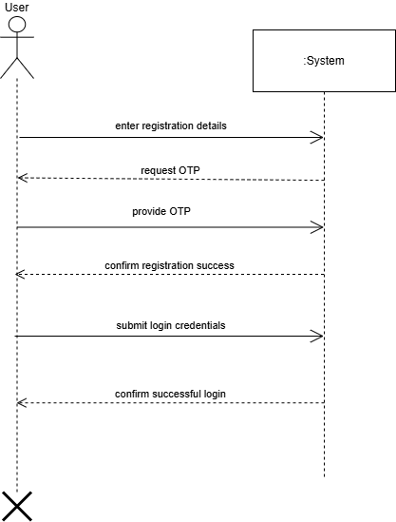

Breakdown Assistance
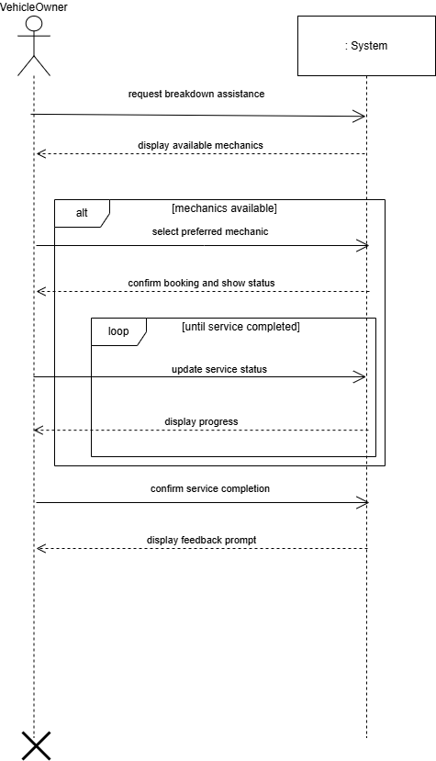

Temporary Driver
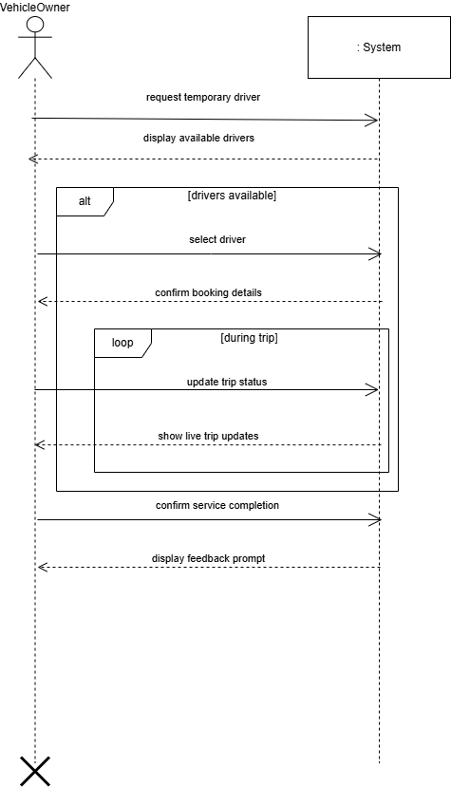

Fuel Delivery
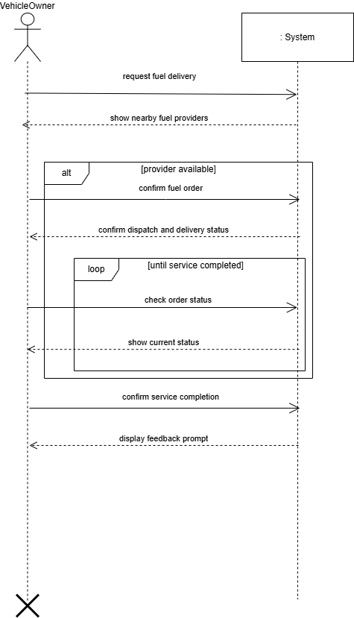

Lockout
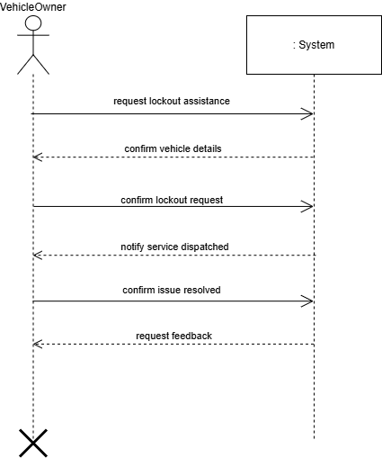

Towing
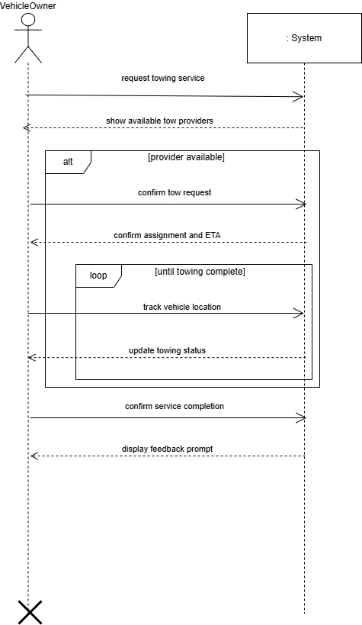

Admin Approvals for Registration
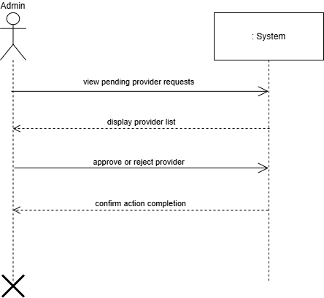

Resolve Dispute
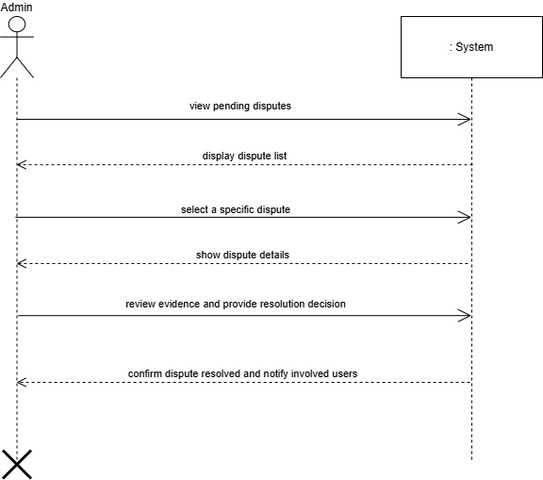

Manage Request
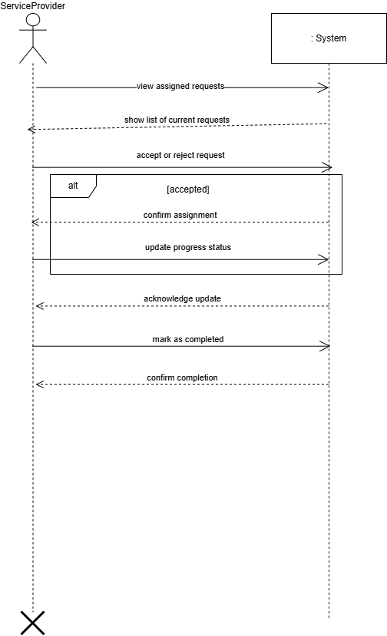

Design Phase Artifacts

Behavioral Design

Activity Diagram
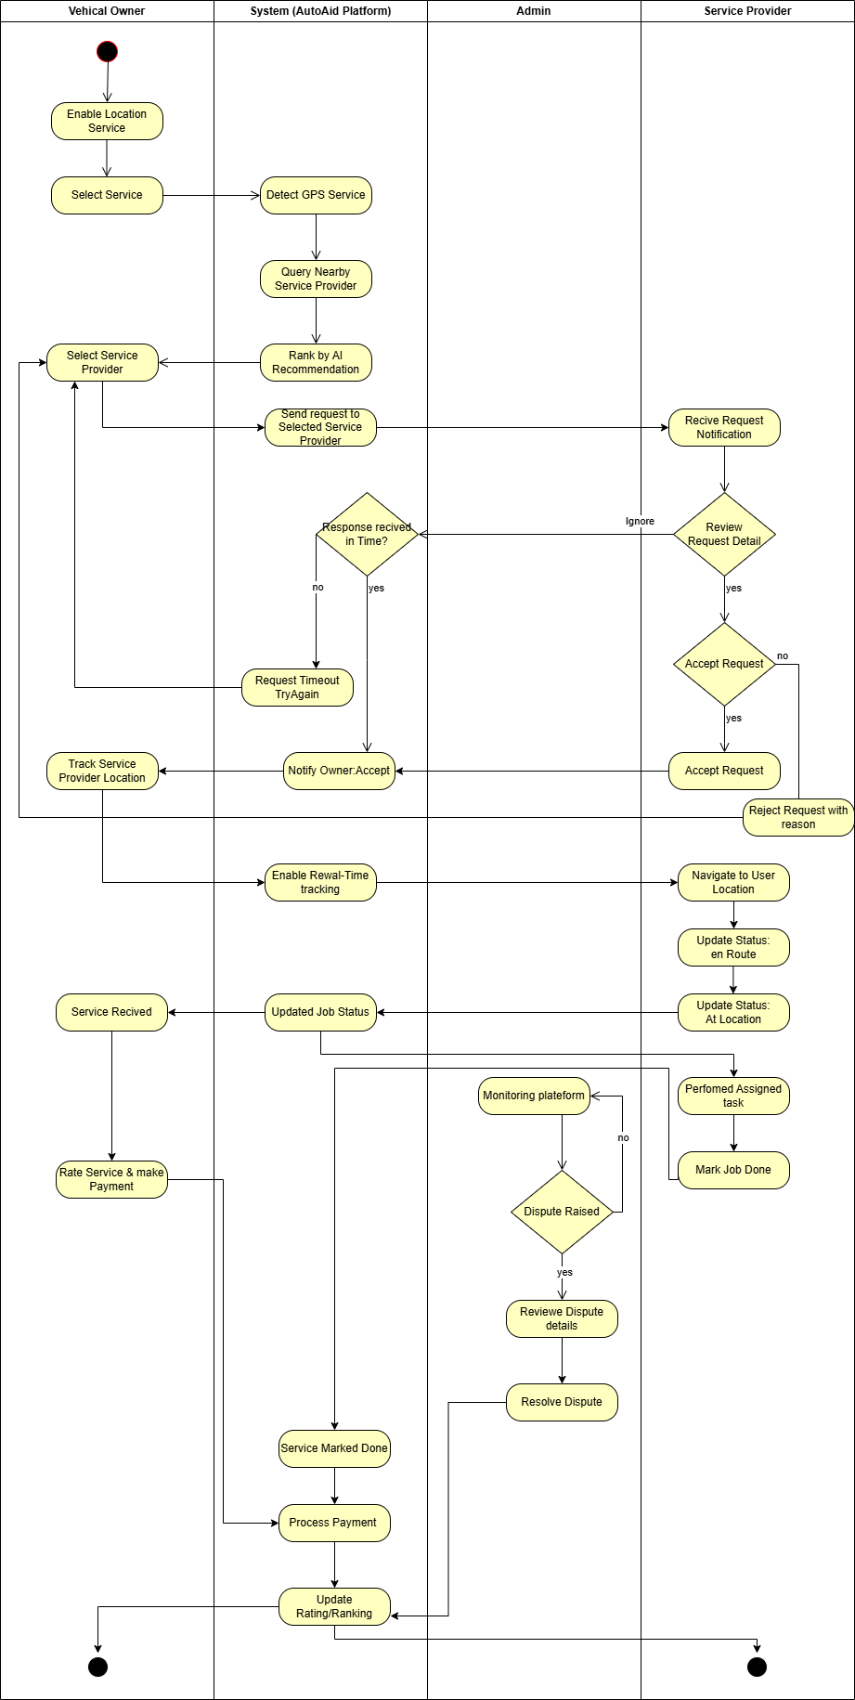

DFD

Level 0:
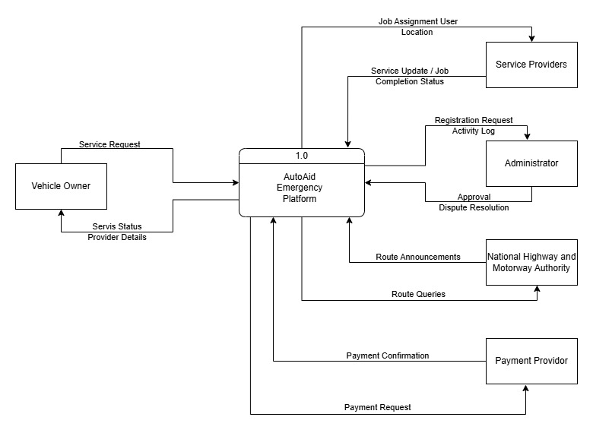

Level 1:
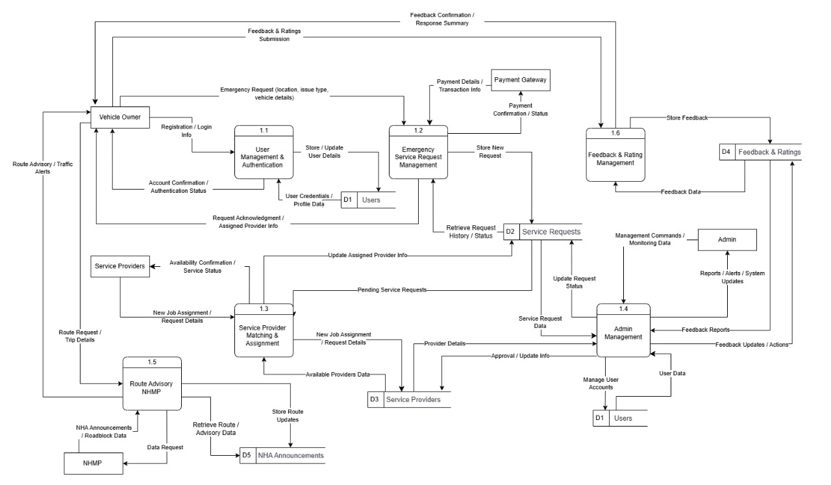

Level 2:
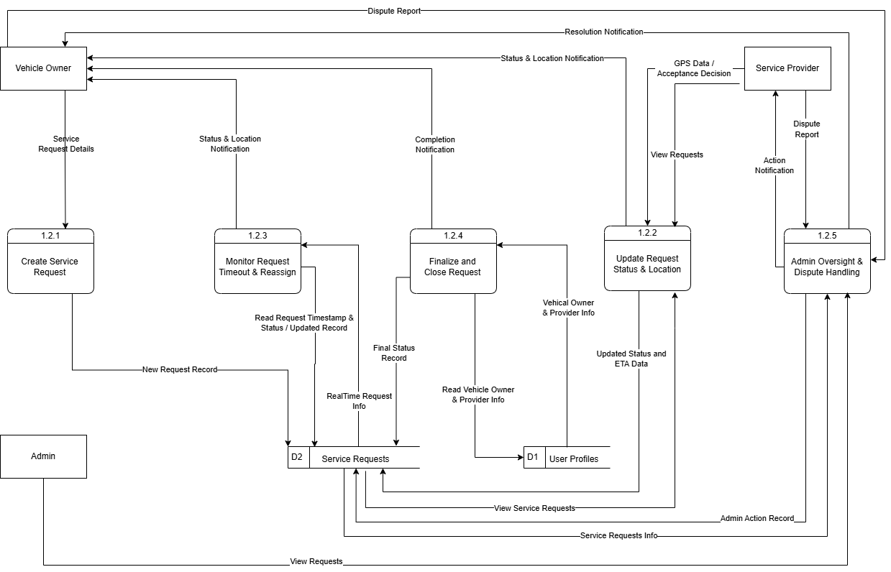

Level 2:
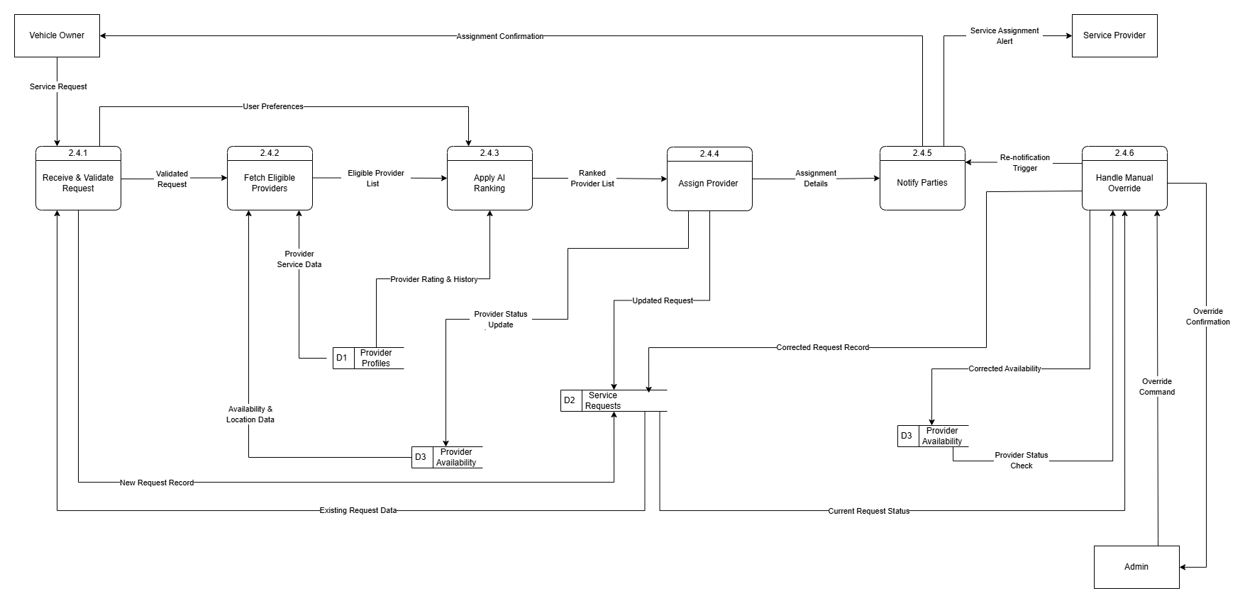

Structural Design

Domain Model
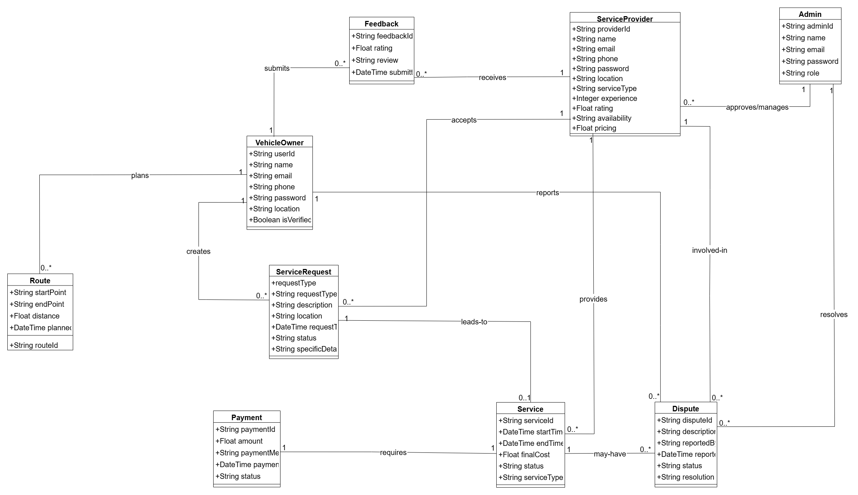

Component Diagram
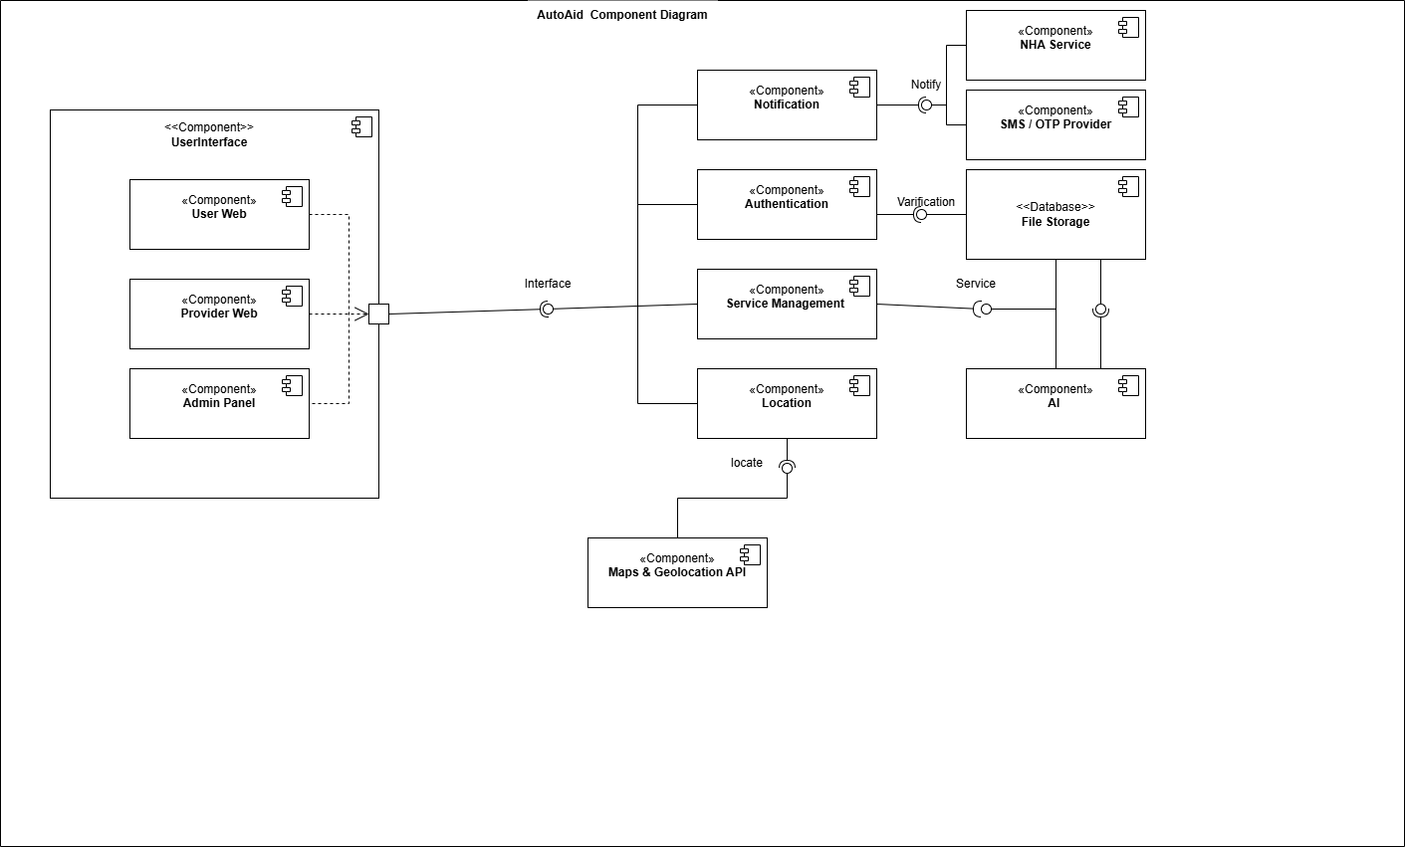

Package Diagram
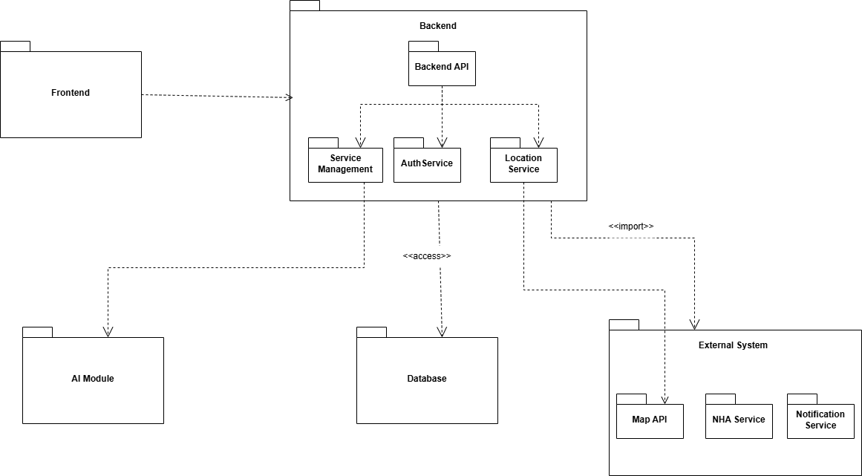

Database Design
